 | Project Design Phase-II
 | Technology Stack (Architecture & Stack)
Date |  | 11 October 2022
Team ID |  | PNT2022TMID13098
Project Name |  | Project – Car Resale Value Prediction
Maximum Marks |  | 4 Marks

Technical Architecture:

The Deliverable shall include the architectural diagram as below and the information as per the table1 & table 2
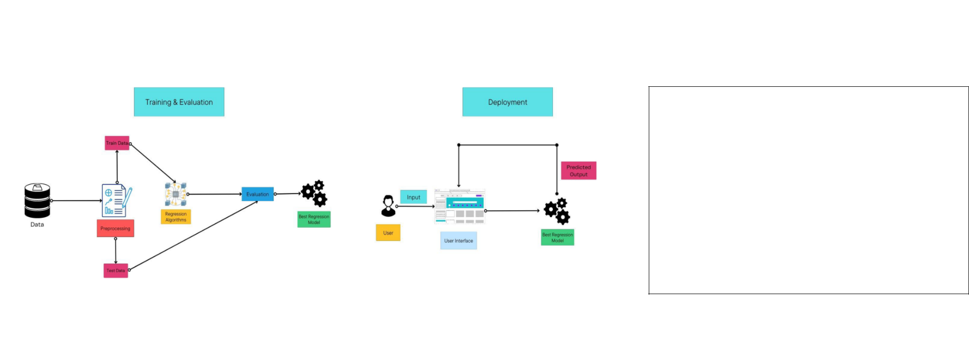

Guidelines:

1. Include all the processes (As an application logic / Technology Block)

2. Provide infrastructural demarcation (Local / Cloud)

3. Indicate external interfaces (third party API’s etc.)

4. Indicate Data Storage components / services

5. Indicate interface to machine learning models (if applicable)
Table-1 : Components & Technologies:

S.No | Component |  | Description |  | Technology
1. | User Interface |  | How user interacts with application e.g. |  | HTML, CSS, JavaScript / React Js etc.
 |  |  | Web UI, Mobile App, Chatbot etc.
2. | Application Logic-1 |  | Logic for a process in the application |  | Python
3. | Database |  | Data Type, Configurations etc. |  | NoSQL
4. | Cloud Database |  | Database Service on Cloud |  | IBM DB2
5. | File Storage |  | File storage requirements |  | IBM Block Storage
6. | Machine Learning Model |  | Purpose of Machine Learning Model |  | Regression model
7. | Infrastructure (Server / Cloud) |  | Application Deployment on Local System / Cloud |  | Local, Cloud Foundry, Kubernetes, etc.
 |  |  | Local Server Configuration:
 |  |  | Cloud Server Configuration :
Table-2: Application Characteristics:
S.No | Characteristics |  | Description |  | Technology
1. | Open-Source Frameworks |  | List the open-source frameworks used |  | Technology of Opensource framework
2. | Security Implementations |  | List all the security / access controls implemented, |  | e.g. SHA-256, Encryptions, IAM
 |  |  | use of firewalls etc. |  | Controls, OWASP etc.
3. | Scalable Architecture |  | Justify the scalability of architecture (3 – tier, |  | Technology used
 |  |  | Micro-services)
4. | Availability |  | Justify the availability of application (e.g. use of |  | Technology used
 |  |  | load balancers, distributed servers etc.)
5. | Performance |  | Design consideration for the performance of the |  | Technology used
 |  |  | application (number of requests per sec, use of
 |  |  | Cache, use of CDN’s) etc.

